## ABOUT THIS DOCUMENT

#### INTRODUCTION

This Manual has been written for Flight Training Schools (FTS) to meet their responsibilities as part of the RAAus Aviation Safety Management System (ASMS).

Where text is written in [blue] the intent is that CFIs may choose to insert the relevant information or delete information to reflect the individual characteristics of their FTS and/or align with their tiered category. The below table provides guidance to CFIs on determining what tier their school will operate under within the RAAus ASMS and is provided as advisory material only. The decision for which tier a FTS fits lies with the school itself and RAAus is available to assist FTSs determine the best fit for their business.

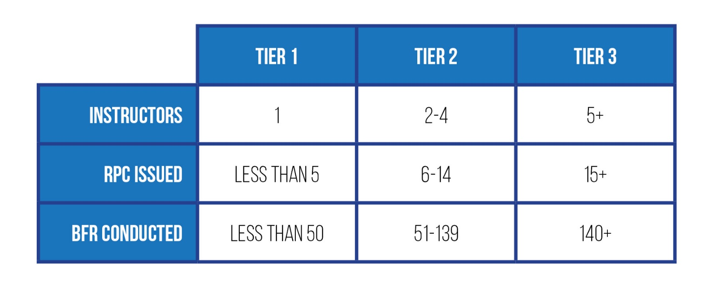**This template has been produced for completion by Tier 1 & 2 Schools**

**WHY?**

It is a Federal Government and CASA requirement that all Approved Self-Administering Aviation Organisation (ASAO) have in place an operating SMS. However, there are sound business and safety reasons for this to be embraced by FTS management and integrated in to operations:

* It forms a structured approach to safety management – less likely to miss critical hazards, risks and mistakes
* It is a formal acknowledgement of what we are already doing – a properly presented document holds more weight in a legal setting than a witness statement which involves interpretation of the ‘facts’
* Significant evidence shows that an ASMS approach reduces direct costs (aircraft/equipment damage, lost time from injuries) and indirect costs (insurance implications, business reputation)

**WHEN?**

To facilitate an organisation wide implementation, the FTS Safety Manual should be up and running in schools by **1 March 2019**.

FTS should aim to commence this transition as soon as possible. There is no need to wait! From 1 July 2019 it is expected that all RAAus FTS will have an ASMS, or similar, in place.



**PART 1**

**Aviation Safety Manual**

Please complete the sections in [blue] from the template below – Once finalised this document is to be printed and kept in an appropriate location for use by Flight Training School Staff.

If you have any queries in relation to this document then please contact [safety@raa.asn.au](mailto:safety@raa.asn.au) or phone 02 6280 2700 and our staff will be more than happy to assist you in completing your ASMS requirements.

[FTS NAME]

# FLIGHT TRAINING SCHOOL AVIATION SAFETY MANUAL

[FTS & RAAUS LOGO]

[FTS LOCATION]

Copyright © 2018 by Recreational Aviation Australia Ltd

All rights reserved. No part of this publication may be reproduced, distributed, or transmitted in any form or by any means, including photocopying, recording, or other electronic or mechanical methods, without the prior written permission of the publisher, except in the case of brief quotations embodied in critical reviews and certain other non-commercial uses permitted by copyright law. For permission requests, write to the publisher at the address below.

Recreational Aviation Australia   
PO BOX 1265  
Fyshwick ACT 2609

**RAAus Template v1.0**

***[Insert Date Here]***

### Document Control

#### Revision History

|  |  |  |  |
| --- | --- | --- | --- |
| **VERSION**  **NUMBER** | **REVISION**  **AUTHOR** | **EFFECTIVE DATE** | **PURPOSE** |
| v.1.0 | RAAus Safety |  | Initially Release May 2018 |
| v.2.0 | RAAus Safety | 18/02/2019 | ASMS Update Feb 2019 |
| v.2.1 | *[Insert FTS Name]* | *[Insert Date Name]* |  |
| v.2.2 | *[Insert FTS Name]* |  |  |
| v.2.3 | *[Insert FTS Name]* |  |  |
|  |  |  |  |
|  |  |  |  |
|  |  |  |  |
|  |  |  |  |
|  |  |  |  |
|  |  |  |  |
|  |  |  |  |
|  |  |  |  |

### Definitions

| TERM | DEFINITION / INTERPRETATION |
| --- | --- |
| Accident | 1. a person dies or suffers serious injury as a result of an occurrence associated with the operations of an aircraft; or 2. The aircraft is destroyed or seriously damaged as a result of an occurrence associated with the operation of the aircraft; or 3. Any property is destroyed or seriously damaged as a result of an occurrence associated with the operation of the aircraft. |
| As Low As Reasonably Practical | means a risk is low enough that attempting to make it lower, or the cost of assessing the improvement gained in an attempted risk reduction, would actually be more costly than any cost likely to come from the risk itself. |
| Change management | a systematic approach to controlling changes to any aspect of processes, procedures, products or services, both from the perspective of an organisation and of individuals. Its objective is to ensure that safety risks resulting from change are reduced to as low as reasonably practicable. |
| School | (Name of School) Flight Training School |
| School Safety Coordinator (SSC) | person responsible for managing all aspects of a school’s safety management system. |
| Hazard | a source of potential harm. |
| Incident | An occurrence which could affect aviation safety but did not result in an accident. |
| Just culture | an organisational perspective that discourages blaming the individual for an honest mistake that has contributed to an accident or incident. Sanctions are only applied when there is evidence of a conscious violation, or intentional, reckless, or negligent behaviour. |
| Likelihood | a general description of probability or frequency that can be expressed qualitatively or quantitatively. |
| Management | planning, organising, resourcing, leading or directing, and controlling an organisation (a group of one or more people or entities) or effort for the purpose of accomplishing a goal. |
| Occurrence Management System (OMS) | The RAAus System accessible online through the website for lodging occurrences, hazards and defects to RAAus. The OMS also provides a confidential complaint mechanism. |
| Responsible Officer | A person authorised by RAAus to provide services. E.g. Instructors, Senior Instructors, Chief Flying Instructor, Pilot Examiners and Regional Operations Coordinators, L2, L3 and L4 Maintenance Approval holders. |
| Residual Risk | The risk remaining after risk treatments have been applied. |
| Risk | the chance of something happening that will have an impact on objectives.   * A risk is often specified in terms of an event or circumstance and any consequence that might flow from it. * Risk is measured in terms of a combination of the consequences of an event, and its likelihood. * Risk can have a positive or negative impact |
| Risk assessment | the overall process of risk identification, risk analysis and risk evaluation. |
| Risk identification | the process of determining what, where, when, why and how something could happen. |
| Risk management | the culture, processes and structures directed towards realising potential opportunities whilst managing adverse effects. |
| Safety culture | an enduring set of beliefs, norms, attitudes, and practices within an organisation concerned with minimising exposure of the workforce and the general public to dangerous or hazardous conditions. A positive safety culture is one which promotes concern for, commitment to, and accountability for, safety. |
| Aviation safety management system (ASMS) | a systematic approach to managing aviation safety, including the necessary organisational structures, accountabilities, policies and procedures. |
| Safety | the state in which the probability of harm to persons or property is reduced to, and maintained at, a level which is as low as reasonably practicable through a continuing process of hazard identification and risk management. |
| Serious injury | Any serious injury or illness that results in:  (i) immediate hospital treatment as an in-patient  (ii) immediate treatment for serious injuries (for example amputation, scalping, a spinal injury, loss of a bodily function or a serious laceration, burn, head injury or eye injury), or  (iii) medical treatment within 48 hours of exposure to a substance. |
|  |  |
|  |  |
|  |  |
| [add in as required] |  |
|  |  |
|  |  |
|  |  |

## SAFETY POLICY STATEMENT

#### Vision

___

*[i.e. Strategic statement about your safety vision. Example:]*

The management team of this school is committed to providing safe, healthy, secure work conditions and fostering positive safety attitudes.

#### Safety Commitment

___

*[i.e., values to guide your staff in achieving your safety vision. Example:]*

I/we are committed to:

* Manage safety at the same level as other major dimensions (technical, financial, sales, etc.) in the Company’s management system
* Recognise safety as the primary responsible of all managers, staff, instructors and maintainers
* a culture of open reporting of all safety hazards and occurrences through the RAAus OMS
* an open reporting culture in which management will not initiate disciplinary action against any personnel who, in good faith, disclose a hazard or safety occurrence resulting from unintentional conduct
* supporting effective communication throughout the organisation
* support for safety training and awareness programs
* conducting regular audits of safety policies, procedures and practices
* monitoring industry activity to ensure best safety practices are incorporated into the organisation
* providing the necessary resources to support this policy
* requiring all employees to maintain a safe work environment through adherence to approved policies, procedures, and training; and familiarising themselves, (and complying), with safety policies and procedures
* all levels of management, starting with the owner/president and Chief Flying Instructor, being accountable for safety performance
* the principle that the organisation is strengthened by making safety excellence an integral part of all activities

(Name)

Owner

(FTS Name) Flight Training School

Date

(Name)

Chief Flying Instructor

(FTS Name) Flight Training School

Date

## SMS COMPONENT 1: SAFETY POLICY AND OBJECTIVES

### 1.1 Responsibilities

All participants in this school’s activities are to take shared responsibility for their own and other’s safety in all aspects of the school’s activities. This applies not only to operational activities but includes general hazard identification and reporting. Everyone is encouraged to report possible hazards or potential risks to the school management and through the RAAus OMS.

Specific responsibilities for safety in the school are outlined below.

#### 1.1.1 Safety Representatives

|  |  |  |  |  |
| --- | --- | --- | --- | --- |
| **Position** | **Name** | **Contact**  **Number** | **Email** | **Remarks** |
| Owner |  |  |  |  |
| Chief  Flight Instructor |  |  |  |  |
| School Safety  Coordinator |  |  |  |  |
| Senior Instructor |  |  |  |  |
| Senior Instructor |  |  |  |  |
| Senior Instructor |  |  |  |  |
| Instructor |  |  |  |  |
| Instructor |  |  |  |  |
| Instructor |  |  |  |  |
|  |  |  |  |  |

#### 1.1.2 Owner

The owner will:

1. Actively support and promote the SMS.
2. Ensure that he/she and all staff comply with the SMS processes and procedures.
3. Ensure that resources are made available to achieve the outcomes of the SMS.
4. Monitor ongoing activities to ensure a safe environment for participants.

#### 1.1.3 Chief Flying Instructor

In addition to his/her overall responsibility for Flight Training School safety, The CFI will:

1. Appoint an appropriate and qualified person to the position of School Safety Coordinator or equivalent (for small schools this may be the CFI)
2. Chair school safety committee meetings and appoint appropriate members responsible for follow up action
3. Promote and ensure an open and fair reporting culture
4. Maintain oversight of Risk Management EITHER [through a risk register and associated risk matrix] OR [through risk profiling to ensure at a minimum the safety of the public, employee/volunteers and the informed participant]
5. Ensure timely incident follow up and feedback given to other members
6. Attend and/or be proactive in developing an “Airport Users Safety Committee” to enable an airport wide safety forum that meets periodically
7. Action any immediate safety actions or safety recommendation from RAAus

#### 1.1.4 **School Safety Coordinator**

The School Safety Coordinator (SSC), reflecting his/her critical role in safety, has direct access to all management levels.

His/her specific responsibilities include:

1. Implement, maintain, review and revise the Flight Training School RAAus ASMS Manual
2. Provide safety advice to school management, staff and instructors
3. Encourage a fair and open reporting culture with all members
4. Promote safety awareness and a positive safety culture
5. Schedule periodic Safety Committee meetings
6. Ensure all incidents and accidents are reported through the RAAus OMS within approved timeframes
7. Oversee any “immediate safety actions” or “safety recommendation” from RAAus
8. Maintain a [risk register and an associated risk matrix OR risk profile.]
9. Identify any ASMS related training requirements; e.g., safety induction and/or airside access for members or visiting contractors
10. Oversee internal and external SMS audit programs
11. Maintain the emergency response plan (ERP)
12. Attend and/or be proactive in developing an [Airport Users Safety Committee or Runway Safety Program] to enable an airport wide safety committee that meets [insert frequency].
13. Safety Meeting Minutes [Tier 2&3: produce meeting minutes and communicate to all staff, affiliated members, relevant stakeholders and make available to RAAus Safety] / [Tier 1: Journal meeting notes in diary or operational log].
14. Provide Risk Profile/Risk Register and any associated Risk Management Plans to RAAus on request

#### 1.1.5 Senior Instructor

In addition to his/her responsibilities under [insert school name here], under this SMS the senior instructor’s responsibilities include:

1. Contribute as a member of the School Safety Committee.
2. Encourage all members under his/her control to report incidents or hazards through the RAAus OMS and take follow up action as necessary.

#### 1.1.6 Instructor

In addition to his/her responsibilities under [insert school name here], under this SMS the instructors responsibilities include:

1. Contribute as a member of the School Safety Committee.
2. Identify and report incidents and hazards of which he/she becomes aware; not just specifically related to aircraft operations through the RAAus OMS.

#### 1.1.7 School Safety Committee

The school safety committee will have scheduled meetings [insert frequency here] and will notify all members in advance.

All school members are invited to attend. Regular and required members of the committee are:

* School Owner
* CFI (Responsible Officer) - committee chair
* SSC – minutes and agenda [tier 2/3], diary entry [tier 1] (committee chair in the absence of the CFI)
* [Other key safety staff where deemed necessary]
* Senior Instructor(s)

The school safety committee is committed to action on safety related matters and its role includes:

1. Reviewing action taken following accidents or incidents
2. Making decisions to fix safety hazards
3. Reviewing risk assessments based on hazard identification
4. Assisting the School Safety Coordinator in the maintenance of a [risk profile and matrix OR risk register].
5. Reviewing internal safety audits
6. Reviewing communications methods to advise members of safety related matters
7. Reviewing school safety objectives and targets
8. Provide a copy of version 1 of this manual to RAAus Safety for approval and then the latest version upon request annually thereafter

Draft Safety Committee Agenda is at Appendix A.

### 1.2 Safety Objectives

The school safety committee will formally review safety objectives yearly. Our initial objectives are:

|  |  |  |
| --- | --- | --- |
| **Safety Objective** | **Target** | **Measurement/KPI** |
| **Short Term Objectives** |  |  |
| Implement initial school ASMS | ASAP and ideally not later than  01 March 2019 | All instructors, managers and any other critical members fully briefed and inducted in the ASMS manual |
| A culture of open reporting of all safety hazards and occurrences through the RAAus OMS | 100% of incidents formally reported | Number of reports received?  Number of known incidents known not to have a formal report (list them) |
| Insert as required | Insert as required | Insert as required |
| **Longer Term Objectives** |  |  |
| Encourage active participation in SMS provisions by all senior staff | Ongoing | Greater than 90% attendance by senior members at safety meetings |
| Safety training and awareness programs (suggestion for Tier 3) | Implement a number of safety training initiatives (suggestion for Tier 3) | Number of staff who completed safety training and what type of training was conducted. Maintain a Safety Training Register. (suggestion for Tier 3) |
| Conducting regular audits of safety policies, procedures and practices (suggestion for Tier 3) | Develop an audits and inspections programme for the company and complete all scheduled audits/inspections (suggestion for Tier 3) | How many audits and inspections were completed this reporting period (suggestion for Tier 3) |

**1.3 Emergency Response Plan (ERP)**

The CFI or, in his/her absence, the SSC will control any emergency associated with the school. Any information regarding the emergency is to be passed to him/her immediately and instructions on required action will be issued by him/her.

The CFI will nominate members to be part of an incident response team and their details will be promulgated to all members.

Emergency procedures covering various possible emergencies will be exercised every [insert timeframe] on a rotation basis, e.g., response to fire, response to in flight emergency, response to a ground based incident/accident.

The SSC is responsible for maintaining the local ERP. Instructors and members are encouraged to have input.

**IMPORTANT!** In the absence of the CFI/SSC any member should use this section of the Manual to the best of their ability to initiate an emergency response. At an absolute minimum all member should understand the requirement to call 000 and JRCC for all aircraft emergencies and 000 for all non-aviation related emergencies.

Those responsible for initiating an emergency response should be able to advise emergency services of the presence of any ballistic parachute on involved aircraft(s).

Detailed information on the school emergency response plan is attached as Appendix B.

### 1.4 Framework Milestones

The Framework for integration of the RAAus SMS within School operations:

|  |  |  |
| --- | --- | --- |
| **Milestone** | **Implement by** | **Notes** |
| **FTS Safety Manual Introduction** |  |  |
| Safety Toolbox released on CFI portal | by End of April 18 | Electronic safety toolbox will have;   1. Instruction Page, 2. Editable FTS Safety Manual, and 3. All templated documents required. |
| RAAus PDP sessions around the country. | February – June 18 | CFIs coached on the development their Safety Manual. |
| **SMS Implementation** |  |  |
| Each CFI to nominate SSC and determined school Tier. Advise RAAus Safety [safety@raa.asn.au](mailto:safety@raa.asn.au). | ASAP but NLT  01 July 18 | Note: RAAus Safety in consultation with the NOM may change requested tier in some unique circumstances. |
| SSC develop Risk Profile/Risk Register and Emergency Response Plan. Submit first version to RAAus Safety [safety@raa.asn.au](mailto:safety@raa.asn.au). | ASAP but NLT  01 August 18 | Tier 3 FTS - risk register  Tier 1 at a minimum must use a risk profile, and Tier 2 may choose either. |
| SSC draft initial FTS Safety Manual and submit to RAAus Safety for review. | ASAP but NLT  01 September 18 | CFIs to develop FTS Safety Manual and induct all staff.  RAAus Safety will conduct a table top review of each FTS Safety Manual progressively from 1 Oct – 1 Dec 18. |
| RAAus SMS Implementation Complete | 01 October 18 | RAAus aims to have all FTS Safety Manuals in place by this date. |
| **SMS Review** |  |  |
| RAAus Audit and Assurance Program Commences | Commence  01 February 19 | Three-fold audit and assurance program encompassing Operational, Safety and Technical aspects of each FTS. |
| Annual safety training on the ASMS at each FTS for all new and existing staff. Conducted by the FTS. | From 2019 onwards | Each tier 3 FTS is required to conduct one half-day safety stand-down per calendar year to conduct ASMS component training and review.  Tier 1 and 2 FTS are encourage to have Safety stand-downs or equivalent. |
| Safety Manual Version 2.0 | TBA (2019) | To align with CFI feedback, audits and CASA approval as part of CASR Part 149 transition. |
| All RAAus FTS operating within the ASMS | 30 Jun 2019 | RAAus FTS cannot operate past this date without the RAAus FTS Safety Manual or equivalent. |

## SMS COMPONENT 2: SAFETY RISK MANAGEMENT

The policy of this school is to identify and minimise weaknesses and hazards BEFORE they can cause an accident or incident.

All members are encouraged and required to report (or fix and report) any issues they feel could pose a risk. This can be done verbally to a senior member or through the RAAus OMS depending on the severity of the problem.

Any senior member of staff receiving a report of this nature is to advise the CFI and report it using the RAAus hazard reporting function within the OMS.

### OMS Reporting Requirements

RAAus members have a responsibility to report all incidents, accidents, hazards and defects to RAAus through the OMS. RAAus also provides a confidential complaint option through the OMS. A member becoming aware of an accident and having completed the immediate phone call requirements within the ERP are to report any accident, incident, hazard or defect to RAAus through the OMS as soon as practical but within 72 hours.

### Reportable Matters to the ATSB

RAAus members have a responsibility under the Transport Safety Regulation to report certain occurrences to the ATSB immediately and/or routinely. Immediately Reportable Matters are covered within the calls to be made matrix at Appendix B. All Routine Reportable Matters are to be submitted to the ATSB in writing. RAAus provides written submissions on behalf of its members provided they report through the OMS within 72 hours.

Note: Members that are aware of an occurrence that is a reportable matter to the ATSB and subsequently choose not to report within the required timeframes will be required to contact the ATSB and provide any required reporting in addition to submitting an overdue occurrence report through the OMS. In these circumstances you may be in breach of the *Transport Safety Investigation Act 2003.*

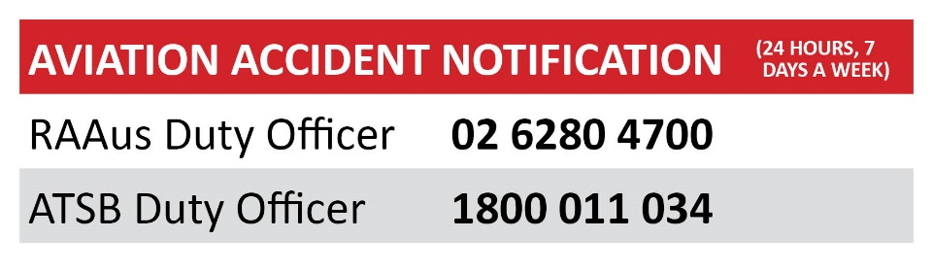

### Hazard Identification

In addition to encouraging all members to report (or fix and report) hazards and weaknesses, the school will:

* Raise the subject of safety and hazard identification at each school meeting
* Review all new and (where necessary) previously reported hazards at school safety meetings
* Conduct an internal assessment of procedures and operations yearly to ensure hazards are being identified and minimised
* Carry out formal hazard identification procedures prior to any change in the school, e.g., expansion of operations, introduction of new equipment or procedures, changes to key personnel or at any time a new risk may be apparent

All reports of hazards are to be directed to the SSC. After verification, he/she will report the data within the school [risk profile/risk register] and where appropriate raise a hazard report within the OMS.

### 2.2 Risk Assessment and Risk Mitigation

The SSC is responsible to hold and maintain the school [risk profile/risk register]. The management of risk is an integral component of our safety management. In controlling hazards and risks, the primary aim is to eliminate the hazard entirely. This may not be always possible. The following table demonstrates a commonly accepted hierarchy of controls.

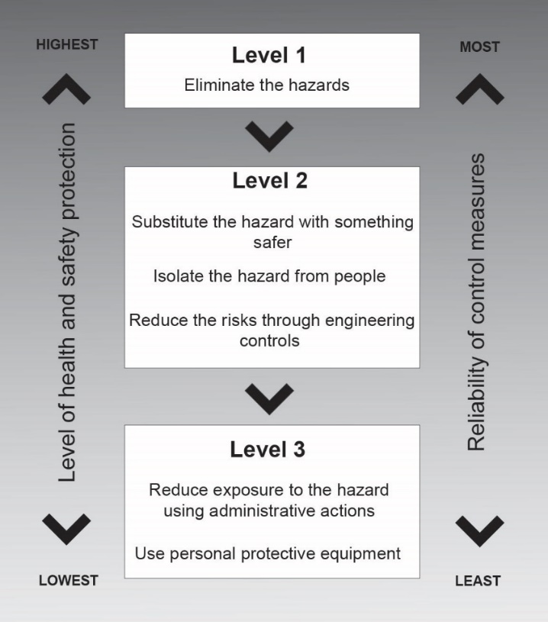

The risk [profile/register] is to be held at the FTS. It is available for all members to read but should not to be removed from the school without approval from the SSC. See [Part C – School Risk Profile OR Part C – Sector Risk Profiles OR Part C – School Risk Register OR Part C – Sector Risk Registers].

The CFI and SSC will take the following steps to ensure that risk management is applied:

Choose the heading that applies to your school.

HEADING 1: Risk Profiling of Flight Training School [Tier 1 and those Tier 2 FTS that choose to use a Risk Profile]

* Hazards are identified and all members are encouraged to participate in the identification of hazards and weaknesses
* Manage identified risks using the hierarchy of risk controls or equivalent
* Place these hazards and associated risks and controls on the school’s Risk Profile
* Ensure that risks, control measures and mitigation strategies are incorporated into relevant communication tools e.g. training lessons, slide shows, induction documentation in addition to listing them on the school’s risk profile
* Periodically review the risk profile for effectiveness of controls

HEADING 2: Risk Register for Flight Training School [Tier 3 and those Tier 2 FTS that choose to use a Risk Register]

* Hazards are identified and all members are encouraged to participate in the identification of hazards and weaknesses
* A risk analysis using a standardised RAAus approved risk matrix is conducted on all identified hazards to assess the probability of an event occurring and the severity of that event
* A clear and logical assessment is made to evaluate the seriousness of possible harm to; persons, equipment, reputation, financial loss, business continuity, the environment and whether these are tolerable or not
* Must publish a risk matrix and define residual risk thresholds that protect the **public, employees, volunteers** and the **informed participant** FTS may wish to consider other dimensions such as **Financial Loss, Reputation** and **Business Capability.**
* Ensure that risks, control measures and mitigation strategies are incorporated into relevant communication tools e.g. training lessons, slide shows, induction documentation in addition to listing them on the school’s risk register
* A periodic review is conducted to ensure the validity and relevance of risks and the employed controls/mitigation measures

### 2.3 Action on Identified Risks

*[After deciding on risk elimination/mitigation strategies, tier 3 schools (and those Tier 2 schools that choose to use risk registers) need to document the actual action taken and review dates for their risk register(s). Tier 1 (and Tier 2 schools that choose to maintain a risk profile) need only document these risks within the risk profile. Schools must have a mechanism in place to remind them/manage an annual review cycle of their adopted risk management tools.] This section should detail how the SCC will document action taken and what review dates are required.*

### 2.4 [RAAus Risk Assessment Matrix Risk Register Only]

*[The Risk assessment matrix at appendix D has been developed for those CFIs that maintain a risk register to simplify this process and may be used should you wish]*

*The matrix at Appendix D is a fillable .pdf that enables CFIs that will operate a risk register to develop a risk assessment matrix that considers risk against multi dimensions (such as Finances, Capability, Reputation…) beyond just the safety of people.*

The [school name] Risk assessment matrix is at Appendix D should CFIs wish to adopt this matrix.

## SMS COMPONENT 3: SAFETY ASSURANCE

The school is aware that the introduction of a new system, like our SMS, is one thing; maintaining it in the intended way is quite another. Instructors, staff and members are entitled to know that their safety is of prime concern to the school and are encouraged to participate in the ongoing maintenance of our safety culture.

### 3.1 Safety Performance Monitoring and Measuring

In addition to the RAAus Audit and Assurance Program, the School, under the leadership of the CFI will measure and monitor our compliance with the RAAus ASMS principles by:

* Reviewing our overall compliance with the RAAus ASMS once every [insert timeframe]. The CFI may delegate this task to a senior member on a rotational basis
* Reviewing our safety objectives and their measurement annually. This review is to be done by the School Safety Committee
* Assessing the effectiveness of our ASMS procedures and processes outlined in this document in regard to their implementation and, importantly, how they are practised by staff and members

### 3.2 Internal Safety Investigation

Members are encouraged to report any occurrences about which they have concern to the CFI and through the RAAus OMS. RAAus investigators will review the report and either investigate or assign an investigation to the local CFI or his/her delegate.

The assigned investigator will:

* Be objective and focus on the ‘what’ and ‘how’ circumstances rather than the person/s
* Ensure that the report is reviewed at the school safety committee meeting to identify if improvements or changes need to be made to procedures
* Determine if any lessons can be drawn from the occurrence
* Suggest if other members or other schools in the area could benefit from the investigation results and report this to RAAus for distribution

### 3.3 Change Management

All members, especially staff, are reminded that any change, particularly to known methods and procedures, can bring further risk which needs identification, management and mitigation. Staff may refer to the RAAus Change Management Policy for further guidance. Change will be managed at a minimum by:

* Risk management procedures being applied to minor changes. The SSC and, if necessary, the CFI are to be kept informed of any proposed changes and the risk management techniques which have been applied
* The School Safety Committee will consider the safety implications of any proposed major changes in the school, e.g., introduction of new equipment, aircraft, additional flight training locations or procedures

### 3.4 Continuous Improvement

After initial introduction of this ASMS, the school needs to remain focused on safety and regularly review our safety net to ensure it is still relevant and working for us.

We will:

* Continuously monitor and annually formally review our risk management process. This will be done through the School Safety Committee
* Implement recommendations from any of our incident investigations and review other incident investigations to determine their relevance to us
* Implement recommendations from our own internal audits and those conducted through the RAAus Audit and Assurance Program
* All members are welcome and invited to attend school safety meetings. The SSC will post notice of meeting dates and agenda in a prominent position within the school precinct. Minutes will be issued and posted as soon as possible after each meeting
* Attend and/or be proactive in developing an “Airport Users Safety Committee” to enable an airport wide safety committee and meet to occur periodically
* Share safety information with the other schools and aerodrome users

### 3.5 Version Control

This manual is a controlled document. The RAAAus Safety Manager in consultation with the CFI of *[FTS Name]* is the authorising officer for Version 1.0. The FTS Safety Committee and SSC is responsible for amending and improving this manual as they deem appropriate. All updates authorised by the FTS Safety Committee or SSC shall change the number to the right of the decimal place.

**Example**: Version 1.0 would be changed to Version 1.1

The RAAus National Safety Manager is also responsible for the continuous improvement of this document. Where RAAus generate an amendment the version number to the left of the decimal place shall change.

**Example**: Version 1.1 would be changed to Version 2.0

When changes are made by head office the SSC of each FTS shall be provided with an electronic update to enable the SSC to update their Manual.

This manual has also been designed to enable future components to be introduced as the FTS and/or head office may require.

## SMS COMPONENT 4: SAFETY PROMOTION

The school is aware that a Safety Management System is of little use unless it is promoted and understood by all members. We will achieve this by a combination of RAAus and local level safety training and ongoing communication programs.

### 4.1 Safety Training

As an initial step, in additional to any training material generated by RAAus the School Safety Coordinator will:

* Brief all staff and instructors on the [insert school name] FTS Safety Manual
* Compile a record of members who have appropriate qualifications, e.g., First Aid (including details of currency including CPR), Cert 4 in WH&S, training or experience in risk management, training or experience in project planning
* Review present safety training and establish its relevance and adequacy, e.g., induction training for new members, staff and instructors, safety briefings for contractors or workers

The safety committee is to review the adequacy and appropriateness of safety training as an agenda item at each safety committee meeting.

### 4.2 Safety Communication

Our safety communication strategy is aimed at ensuring there is unimpeded two-way communication on safety matters. That is, members are kept informed about safety initiatives and feedback is captured and acted upon.

As an initial step and in additional to Safety Communication by RAAus we will:

* Make clear that all members are welcome at safety meetings by posting the agenda and meeting minutes [or equivalent] within the FTS facility
* Make safety signage and communication board(s) obvious and clear
* Require safety critical members to wear high-vis vests when engaged in safety related activities, e.g., refuelling, conducting prefights and moving aircraft in and out of hangars



**PART 2**

**Emergency Response Plan**

Please complete the sections in [blue] from the template below – Once finalised this document is to be printed and kept in an easily accessible location for use by Flight Training School Staff.

If you have any queries in relation to this document then please contact [safety@raa.asn.au](mailto:safety@raa.asn.au) or phone 02 6280 2700 and our staff will be more than happy to assist you in completing your ASMS requirements.

### Appendix B: FTS Emergency Response Plan (ERP) – Next review [insert date]

#### Part A: School Particulars

School Name:

Ph:

School Address (location) *[Insert GPS/ Street Address]*

Specific instructions:

Chief Flying Instructor: Mob:

*[Insert satellite schools and/or other commonly use landing sites]*

**Personnel Trained to Administer First Aid, CPR**

|  |  |
| --- | --- |
| **First Aid, CPR Qualifications** | |
| **Name** | **Telephone** |
|  |  |
|  |  |
|  |  |

**Location of:**

**First Aid Kits**

A First Aid Kit is kept in Manifest in rear office.

**Fire Extinguishers**

* Manifest
* Canteen
* Equipment room
* Each aircraft
* Bus
* Refuelling point
* Hanger
* Accommodation areas

**Fire Alarms fitted and operational**

* [insert Location]

#### Part B: Emergency Protocols

*[This part has been limited to medical emergencies as a guide. Schools may consider including other emergencies like vehicle accidents, other operational fatalities, water landings, etc.]*

**If an aircraft accident is witnessed or has likely occurred and the position is known, dial 000** and request emergency assistance and then call JRCC **1800 815 257.**

**If an aircraft is missing or likely crashed but the position is unknown, call JRCC 1800 815 257** and request emergency assistance.

**If a medical emergency [non-aircraft accident] is reported, dial 000** and request emergency assistance

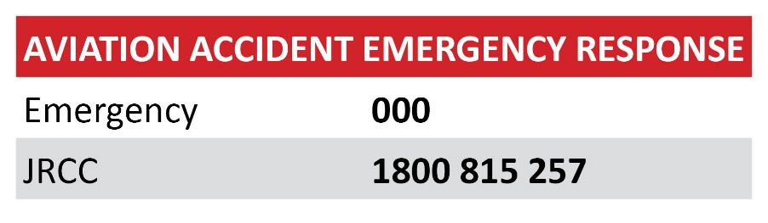

Then provide the following information:

1. Number and location of victim(s)
2. Nature of injury or illness
3. Hazards involved (including existence of Ballistic Parachutes)
4. First aid care being administered
5. Address and nearest entrance (emergency access point/aerodrome crash gates etc.)
6. Any other pertinent information

##### Medical Emergency Response Procedures

* [**CAUTION:** airside access and procedures may apply, SSC is to tailor this section to specific aerodrome requirements]
* Alert any First Aid, CPR trained employees, club members to also respond to victim’s location with a first aid kit
* Ambulance to be met at nearest entrance/emergency access point; direct them to victim(s)
* Any person within the location who is trained in first aid/CPR should respond and provide first aid assistance if possible [**WARNING:** Some aircraft have ballistic parachutes!]
* Control access to the scene
* Take precautions to prevent contact with body fluids
* Handover to emergency services as soon as they arrive on site

##### Secondary Response Procedures

* Preserve wreckage/equipment as found for ATSB investigation. Where the ATSB decides not to investigate then the wreckage/equipment becomes the property of the [insert state or territory police].

#### Part C: Emergency Contact Information

*[Ensure these are KEPT UPDATED. For ease of access, a copy of the emergency contacts list should be prominently displayed in manifest.]*

|  |  |  |  |  |  |  |
| --- | --- | --- | --- | --- | --- | --- |
| **Table One: Emergency Contacts Information** | | | | | | |
| **School Contacts** | | | | | | |
| **Position** | **Name** | | | **Emergency Telephone** | | **Business Telephone** |
| CFI |  | | |  | |  |
| Deputy CFI |  | | |  | |  |
| Senior Instructor |  | | |  | |  |
| Senior Instructor |  | | |  | |  |
| Instructor |  | | |  | |  |
| Instructor |  | | |  | |  |
| Instructor |  | | |  | |  |
|  |  | | |  | |  |
|  |  | | |  | |  |
|  |  | | |  | |  |
| **RAAus Contacts** | | | | | | |
| **Position** | | **Name** | | **Emergency Telephone** | | **Business Telephone** |
| Chief Executive Officer | | *Not Specified* | | 02 6280 4700 (a/h divert) | | 02 6280 4700 |
| National Safety Manager | | *Not Specified* | | 02 6280 4700 (a/h divert) | | 02 6280 4700 |
| National Operations Manager | | *Not Specified* | | 02 6280 4700 (a/h divert) | | 02 6280 4700 |
| National Technical Manager | | *Not Specified* | | 02 6280 4700 (a/h divert) | | 02 6280 4700 |
|  | |  | |  | |  |
|  | |  | |  | |  |
| **Public Emergency Services & Contractors** | | | | | | |
| **Emergency Service Name** | | | **Emergency Telephone** | | **Business Telephone** | |
| Joint Response and Coordination Centre | | | 1800 815 257 | | 1800 815 257 | |
| Air Transport Safety Bureau (ATSB) | | | 1800 011 034 | | 1800 011 034 | |
| Civil Aviation Safety Authority | | | 13 17 57 | | 13 17 57 | |
| Airport Manager | | | [insert number] | | [insert number] | |
| Airport Safety Officer | | | [insert number] | | [insert number] | |
| Aerodrome Reporting Officer | | | [insert number] | | [insert number] | |
| Airport Manager | | | [insert number] | | [insert number] | |
| Airport Safety Officer (satellite) | | | [insert number] | | [insert number] | |
| Aerodrome Reporting Officer (satellite) | | | [insert number] | | [insert number] | |
| Emergency Medical Services | | | 000 | |  | |
| Fire Department | | | 000 | |  | |
| Local Police Department | | | 000 | |  | |
| Local Hospital | | | [insert number] | | [insert number] | |
| Electrician | | | [insert number] | | [insert number] | |
| Regional Council | | | [insert number] | | [insert number] | |
| Plumber | | | [insert number] | | [insert number] | |
| Snake Catcher | | | [insert number] | | [insert number] | |
| Crane and/or Wreckage Disposal Company | | | [insert number] | | [insert number] | |

##### Calls to Make

The following table details the calls that must be made by the school in the event of an emergency. These calls would usually be made by the first person becoming aware of the situation. The order that they are made in would be dependent upon the situation at the time, with calls to 000 and JRCC taking precedence over all else. [Provided within Safety Toolbox as an Excel file so schools can tailor as necessary]

##### 

##### Ballistic Parachutes

##### [Insert details of aircraft with Ballistic Parachutes here] OR

##### [“No aircraft registered for operation within the FTS are fitted with ballistic parachutes”.]

**WARNING:** Ensure emergency services are notified of the presence of any ballistic parachutes prior to any emergency response.

[Insert here any additional emergency response appendices or references to other school manuals as required.]

##### Summary

It is important that all personnel are aware of their role and required actions in the emergency response plan. Emergency plans should be communicated to all club members and participants. This plan shall be reviewed regularly and ideally should be rehearsed at least [annually]. Although incidents may not occur often, a sound, communicated and well-understood emergency response plan may mean the difference between life and death in an emergency situation.



**PART 3**

**Risk Profile**

The following table should be updated with any identified risks associated with the operations at your Flight Training School.

This should be updated for risks specific to your operation including RPT, Parachute Operations, Gliding, Local terrain/conditions, etc.

This table should be expanded over multiple pages to cover risks relating to all areas of operation, not just aircraft operations – Note the information below is provided as examples only and should be reviewed and updated appropriately.

If you have any queries in relation to this document then please contact [safety@raa.asn.au](mailto:safety@raa.asn.au) or phone 02 6280 2700 and our staff will be more than happy to assist you in completing your ASMS requirements.

**Appendix C: Risk Profile**

|  |  |
| --- | --- |
| **Hazard/Associate Risk** | **Mitigation Strategy/Control Measure** |
| Collision on the taxiway | Appropriate briefing and understanding of taxiing, holding point, and right of way procedures while taxing, as well as maintaining communication and situational awareness. |
| Inadequate or incorrect radio transmissions | Ensure radio calls are standardised, students and pilot understand the need for calls when situationally required. Ensure pilots maintain good lookout procedures and do not become dependent on radio transmissions. |
| Weather conditions unique to the area that must be identified and discussed. | Appropriate briefing conducted during training regarding local meteorological phenomena. |
| Engine Failure after takeoff | Maintaining regular EFTO practice and being aware of forced landing options around the local aerodrome. |
| Collision in the circuit | Maintain constant listening watch on the radio and ensure correct circuit procedures are following including joining procedures. Maintain situational awareness in and around the circuit area, including checking windsock direction. |
| Inbound and Outbound Regular Public Transport (RPT traffic) | Implement procedures for students for inbound and outbound RPT traffic, and maintain situational awareness of speed, distance and altitude of RPT traffic |
| Near-miss as a result of difference in performance of aircraft. | Understand procedures for aircraft of different performance, particularly when operating within the circuit. |
| Parachute operations conflicting with circuit aircraft resulting in the death of a parachutist (significant reputational damage). | Form an aerodrome safety committee to discuss and resolve any conflicts before they present a safety risk |
| Glider competitions causing increased risk of near-misses due to circuit integration with other operators. | Appropriate briefing conducted during training regarding local gliding operations, aerodrome safety committee informed prior to the event to ensure conflicts are minimised |
| Lack of runway rejection points and/or go around decision points in training causing an accident on, or, when using the runway. | Ensure students understand decision making and reference points for aborted take-off |
| Collision with terrain or other aircraft due to inadequate cockpit communication leading to student making incorrect inputs or even freezing on the controls. | Develop a crew resource management presentation and discuss this issue in and outside of the cockpit. Practice conducting hand-overs/take-overs ("Handing Over/Taking Over") outside of the cockpit. |
| Aircraft accident as a result of hitting wildlife. | Review aerodrome ERSA entry, report all wildlife issues to Airservices and RAAus via OMS |
| Please complete a risk assessment and add more hazards/risks to this table. Expand further if required. |  |
| FILL OUT THIS TABLE AS REQUIRED |  |
| FILL OUT THIS TABLE AS REQUIRED |  |
| FILL OUT THIS TABLE AS REQUIRED |  |
| FILL OUT THIS TABLE AS REQUIRED |  |
| FILL OUT THIS TABLE AS REQUIRED |  |
| FILL OUT THIS TABLE AS REQUIRED |  |
| FILL OUT THIS TABLE AS REQUIRED |  |
| FILL OUT THIS TABLE AS REQUIRED |  |
| FILL OUT THIS TABLE AS REQUIRED |  |
| FILL OUT THIS TABLE AS REQUIRED |  |



**PART 4**

**Safety Meetings & Local Runway Safety Team**

The following pages may be used to record safety meeting agenda items and meeting minutes. Safety meetings should be held with the appropriate safety committee members at a time frame **not exceeding 12 months.**

Flight Training Schools should form a local runway safety team to discuss safety items with other airfield operators/owners.

It is a requirement that each FTS can show proof of having held a safety meeting to review the school safety manual, risks, and emergency response plan within the preceding 12 months.

If you have any queries in relation to this document then please contact [safety@raa.asn.au](mailto:safety@raa.asn.au) or phone 02 6280 2700 and our staff will be more than happy to assist you in completing your ASMS requirements.

**[Insert School name] SAFETY COMMITTEE MEETING AGENDA**

Date:

Time:

Attendees:

Apologies:

1. Welcome from Chair
2. Previous Meeting minutes
3. SMS Implementation plan – review and update
4. Incident, Accident, Hazard and Defect Reports - Reporting to RAAus
5. Safety Communication
6. Safety Training
7. Emergency Response Plan
8. Other business
9. Next meeting date
10. Chair close the meeting

#### [insert school name] Safety Committee Meeting

|  |  |
| --- | --- |
| Date & Time |  |
| Venue |  |

|  |  |  |
| --- | --- | --- |
| Invitees | Internal | External (optional) |
|  |  |  |
|  |  |  |
|  |  |  |
|  |  |  |
|  |  |  |

|  |  |  |  |
| --- | --- | --- | --- |
|  | **Meeting Minutes** | **Accountable** | **Status / Action** |
| **1.** | **Introduction** | open meeting  Welcome |  |  |
| **2.** | *Previous meeting minutes*  … read previous meeting minutes  … moved the minutes of the previous meeting be accepted,  … seconded |  | Motion carried |
| **3.** | SMS |  |  |
| **4.** | Incident, Accident, Hazard and Defect Reports |  |  |
| **5.** | Safety Communication |  |  |
| **6.** | Safety Training |  |  |
| **7.** | Emergency Response Plan |  |  |
| **8.** | Other Business |  |  |
| **9.** | *Next meeting date* Thursday 11 January 2018 10.00am |  |  |
| **10.** | Chair closed the meeting 11.15am |  |  |
|  |  |  |  |